**Windshield Check**

**4- My windshield is sparkling clean. I understand everything well enough to teach it to my friend.**

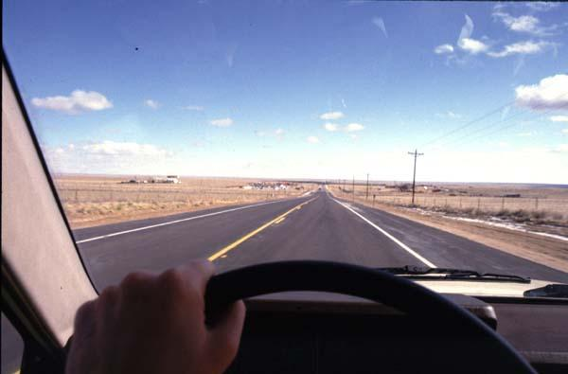

**3- My windshield is clean enough. I understand it pretty well; I just need a little more practice.**

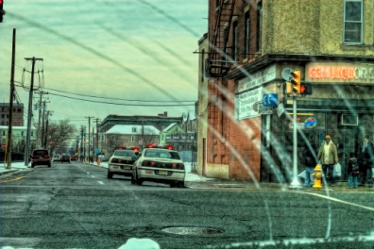

**2- My windshield is a little buggy. I don’t understand everything, I’m learning, but still need help.**

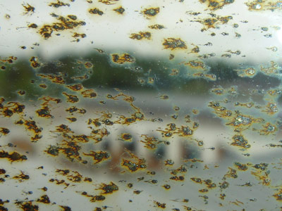

**1- My windshield is muddy. I still don’t understand anything.**

